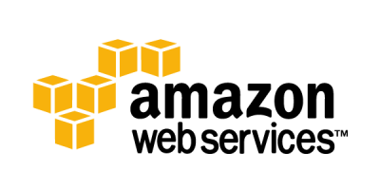

AWS (Amazon Web Services) is a comprehensive, evolving cloud computing platform provided by Amazon that includes a mixture of infrastructure as a service (IaaS), platform as a service (PaaS) and packaged software as a service (SaaS) offerings. AWS services can offer an organization tools such as compute power, database storage and content delivery services.

Today, AWS provides a highly reliable, scalable, low-cost infrastructure platform in the cloud that powers multitude of businesses in 190 countries around the world.

How AWS works

AWS is separated into different services and each can be configured in different ways based on the user's needs. Users should be able to see configuration options and individual server maps for an AWS service.

More than 100 services comprise the Amazon Web Services portfolio, including those for compute, databases, infrastructure management, application development and security. These services, by category, include:

* Compute
* Storage databases
* Data management
* Migration
* Hybrid cloud
* Networking
* Development tools
* Management
* Monitoring
* Security
* Governance
* Big data management
* Analytics
* Artificial intelligence (AI)
* Mobile development
* Messages and notification

**NETWORKING (IP ADDRESS)**

**TYPES OF IP ADDRESS AND ITS REQUIREMENTS**

There are basically two types of IP addresses:

1) Static IP address

2) Dynamic IP addresses/Shared IP address

An IP Address is a 32-bit number that identifies a computer on the Internet. Every web site on the internet is found not by its domain name but by its IP address.

When someone types the address: www.xyz.com it is translated into an IP address and then the computer is directed to that IP address which is the web site.

Now every single website has an IP address specifically allocated to it. If every site assigned a separate IP address then there could be a problem with running out of IP addresses so a lot of the sites on the server use a single IP address for multiple sites.

Thus, using more than one site on an IP address is called a Shared IP address. If a site has its own IP address, and shares with no one else, it is called a Static IP address.

You can always access a site which has a static IP address by using its IP address alone, but you cannot access a site using a shared IP address by typing in the IP address alone because when you type in a shared IP address you arrive at the server but the server does not know which site you are looking for as you have not told it which domain name you want.

**Static IP Addresses:**

As the name indicates, the static IP addresses usually never change but they may be changed as a result of network administration. They serve as a permanent Internet address and provide a simple and reliable way for the communication. From the static IP address of a system, we can get many details such as the continent, country, region and city in which a computer is located, The Internet Service Provider (ISP) that serves that particular computer and non-technical information such as precise latitude and longitude of the country, and the locale of the computer. There are many websites providing IP address lookups. You can find out your IP addresses at http://whatismyip.org/.

**Dynamic IP Addresses:**

Dynamic IP address are the second category. These are temporary IP addresses. These IP addresses are assigned to a computer when they get connected to the Internet each time. They are actually borrowed from a pool of IP addresses, shared over various computers. Since limited number of static IP addresses are available, ISPs usually reserve the portion of their assigned addresses for sharing among their subscribers in this way.

Static IP addresses are considered as less secure than dynamic IP addresses because they are easier to track.

**IP Version 4 and IP Version 6:**

The two versions of IP addresses currently running are IP versions 4 (IPv4) and IP versions 6 (IPv6). There are many features with these two versions

**IP Version 6**

The IPv6 is the most recent version of Internet Protocol. As the Internet is growing rapidly, there is a global shortage for IPv4. IPv6 was developed by the Internet Engineering Task Force (IETF). IPv6 is intended to replace the IPv4. IPv6 uses a 128-bit address and it allows 2128 i.e. approximately 3.4×1038 addresses. The actual number is slightly smaller as some ranges are reserved for special use or not used. The IPv6 addresses are represented by 8 groups of four hexadecimal digits with the groups being supported by colons. An example is given below:

Eg: 2001:0db8:0000:0042:0000:8a2e:0370:7334

**The features of IPv6**

The main features of the IPv6 are listed below.

* IPv6 provides better end-to-end connectivity than IPv4.
* Comparatively faster routing.
* IPv6 offers ease of administration than IPv4.
* More security for applications and networks.
* It provides better Multicast and any cast abilities.
* Better mobility features than IPv4.
* IPv6 follows the key design principles of IPv4 and so that the transition from IPv4 to IPv6 is smoother.

These are the key features of the IPv6 when compared to the IPv4. However, IPv6 has not become popular as IPv4.

**IP Version 4**

IP Version 4 (IPv4) was defined in 1981. It has not undergone much changes from that time. Unfortunately, there is a need of IP addresses more than IPv4 could supply.

IPv4 uses 32-bit IP address. So the maximum number of IP address is 232—or 4,294,967,296.

This is a little more than four billion IP addresses. An IPv4 address is typically formatted as four 8-bit fields. Each 8-bit field represents a byte of the IPv4 address. As we have seen earlier, each fields will be separated with dots. This method of representing the byte of an IPv4 address is referred to as the dotted-decimal format. The bytes of the IPv4 is further classified into two parts. The network part and the host part.

**Network Part**

This part specifies the unique number assigned to your network. It also identifies the class of network assigned. The network part takes two bytes of the IPv4 address.

**Host Part**

This is the part of the IPv4 address that you can assign to each host. It uniquely identifies this machine on your network. For all hosts on your network, the network part of the IP address will be the same and host part will be changing.

**IP address and classes**

The IP hierarchy contains many classes of the IP addresses. Broadly, the IPv4 addressing system is divided into five classes of IP address. All the five classes are identified by the first octet of the IP address.

The classes of IPv4 addresses

The different classes of the IPv4 address are the following:

* Class A address
* Class B address
* Class C address
* Class D address
* Class E address

**Public IP Addresses:**

|  |  |  |
| --- | --- | --- |
| **IP Class** | **IP Address Range** | **No. of hosts and net­works each Class provides** |
| Class A | 1.0.0.1 to 126.255.255.254 | Sup­ports 16.7 mil­lion hosts on each of 126 networks. |
| Class B | 128.1.0.1 to 191.255.255.254 | Sup­ports 65,534 hosts on each of 16,382 networks. |
| Class C | 192.0.1.1 to 223.255.254.254 | Sup­ports 254 hosts on each of 2 mil­lion networks. |
| Class D | 224.0.0.0 to 239.255.255.255 | Reserved for mul­ti­cast groups. |
| Class E | 240.0.0.0 to 254.255.255.254 | Reserved for future use, or Research and Devel­op­ment Purposes. |

**Private IP Addresses:**

|  |  |  |
| --- | --- | --- |
| **IP Class** | **IP Address Range** | **No. of hosts and net­works each Class provides** |
| Class A | 10.0.0.0 – 10.255.255.255 | Sup­ports 16.7 mil­lion hosts. |
| Class B | 172.16.0.0 – 172.31.255.255 | Sup­ports 1,048,576 hosts. |
| Class C | 192.168.0.0 – 192.168.255.255 | Sup­ports 65,536. |

**VPC: Virtual Private Cloud**

**Definition:**

A virtual private cloud (**VPC**) is an on-demand configurable pool of shared computing resources allocated within a public cloud environment, providing a certain level of isolation between the different organizations (denoted as users hereafter) using the resources.

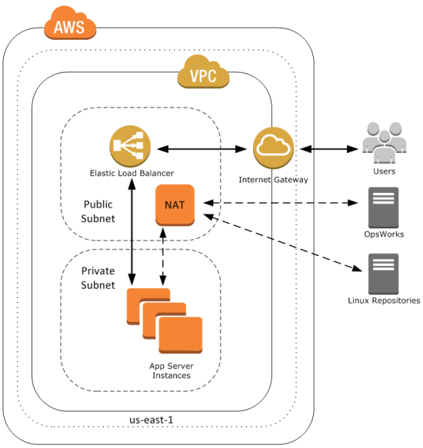

**How Amazon VPCs Work:**

Amazon Virtual Private Cloud (Amazon VPC) enables you to launch AWS resources into a virtual network that you've defined. This virtual network closely resembles a traditional network that you'd operate in your own data center, with the benefits of using the scalable infrastructure of AWS.

**Steps to create VPC:**

**Create VPC (Dashboard)**

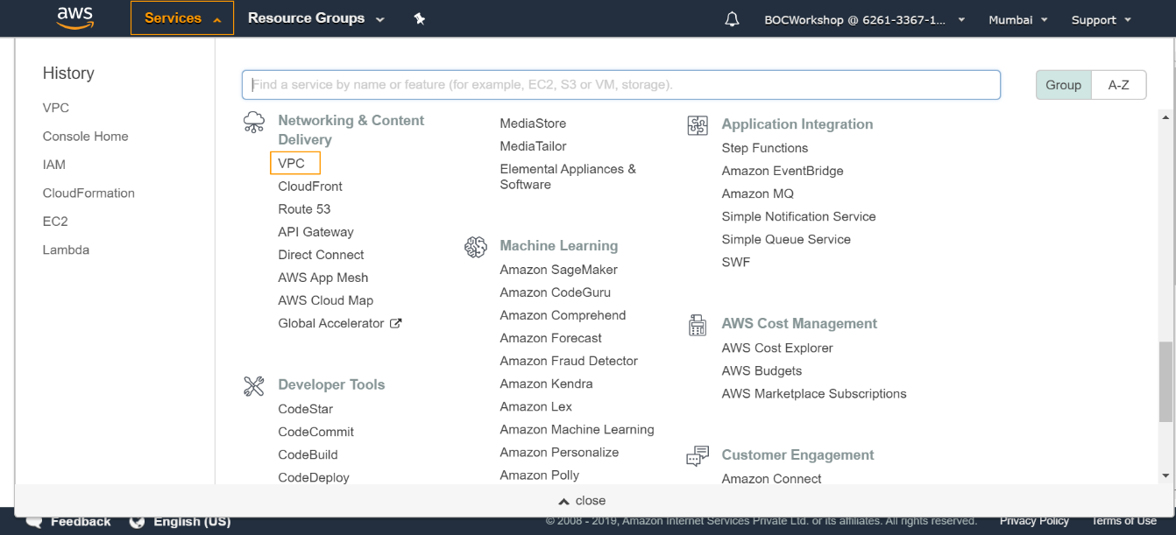

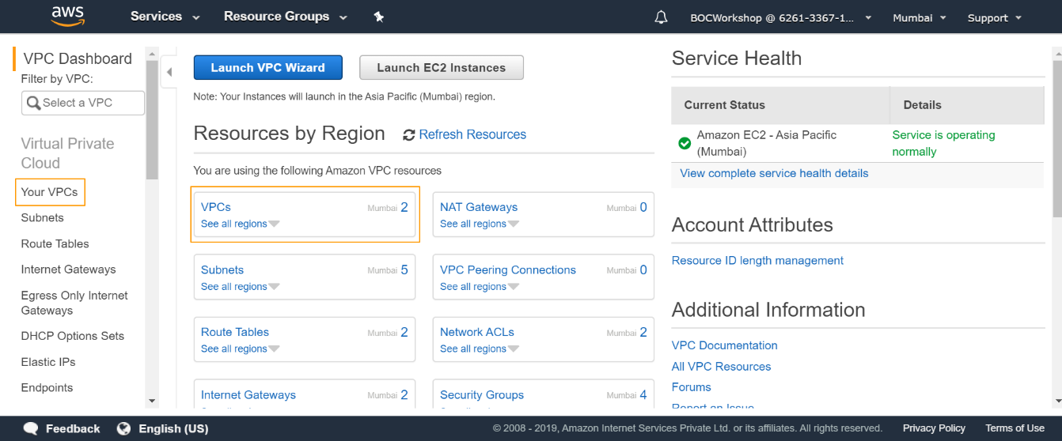

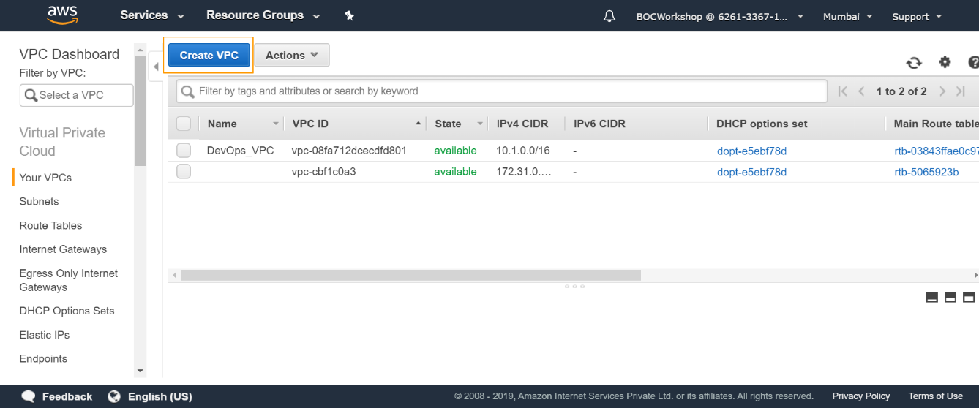

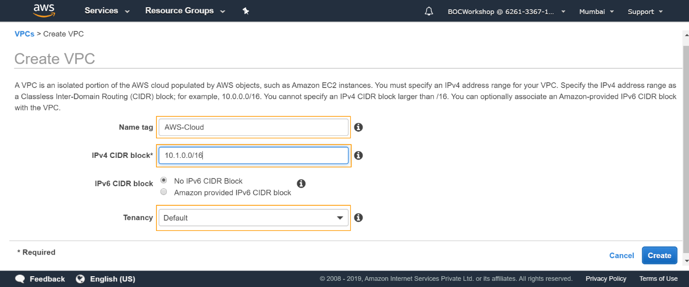

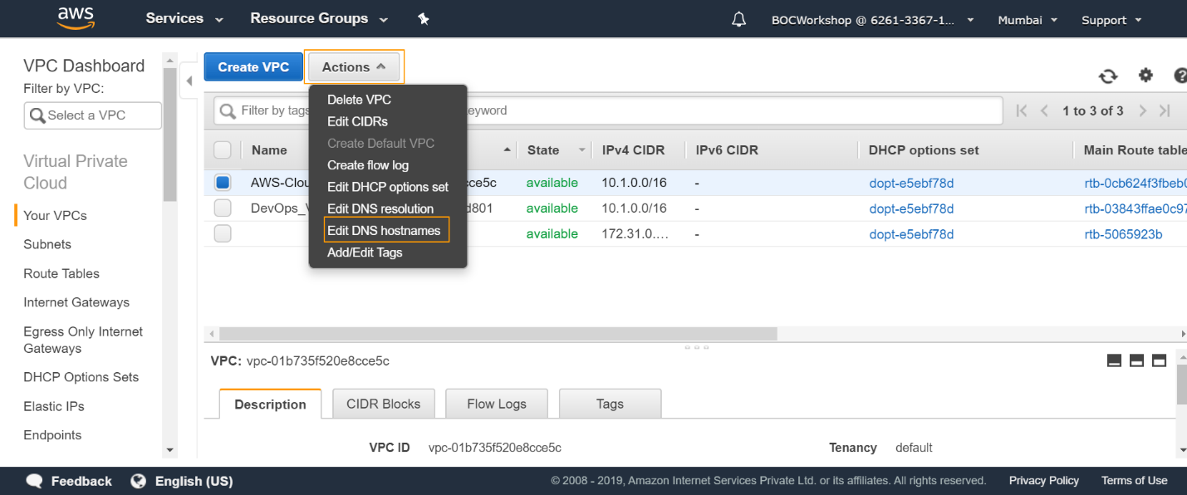

**What is Subnet?**

Subnetwork or subnet is a logical subdivision of an IP network. The practice of dividing a network into two or more networks is called subnetting. AWS provides two types of subnetting one is Public which allow the internet to access the machine and another is private which is hidden from the internet.

Types:

* Public Subnet
* Private Subnet

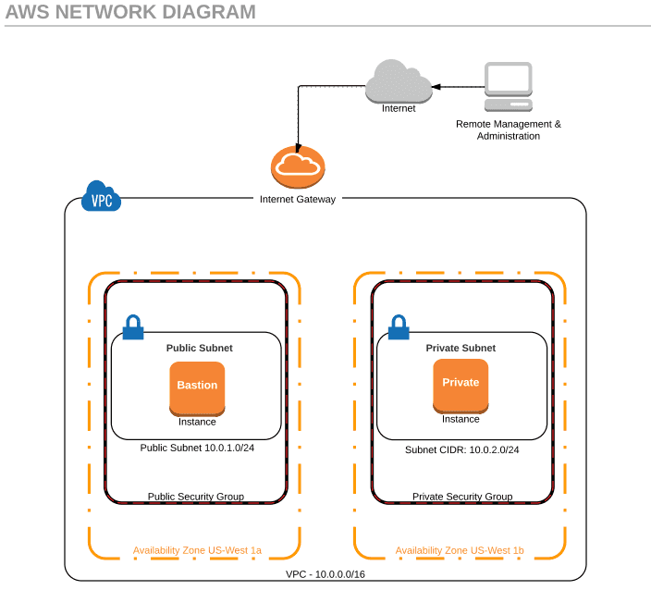

**Create Subnets (Dashboard) – Followed by Screenshots** 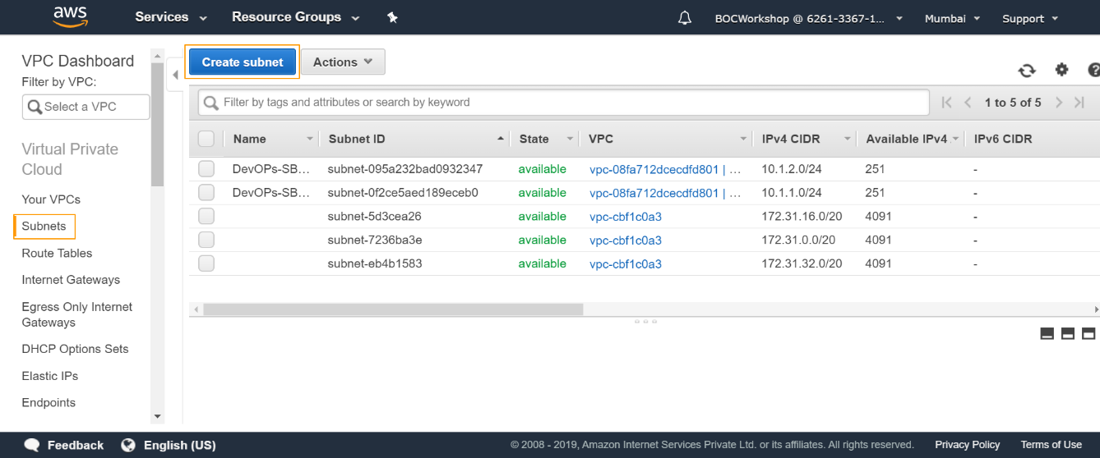

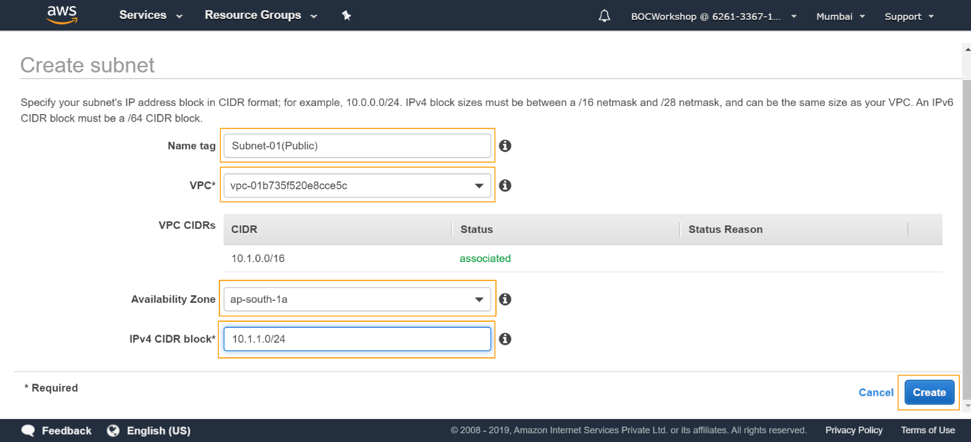

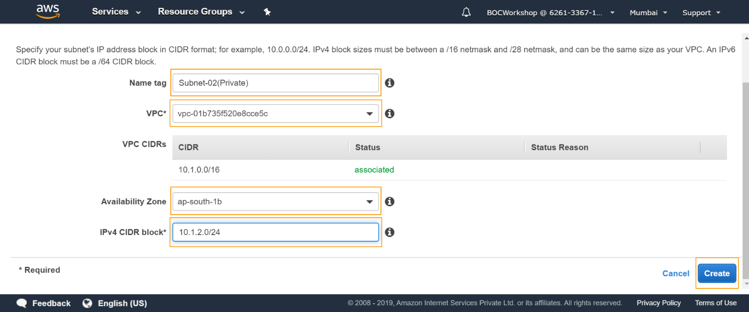

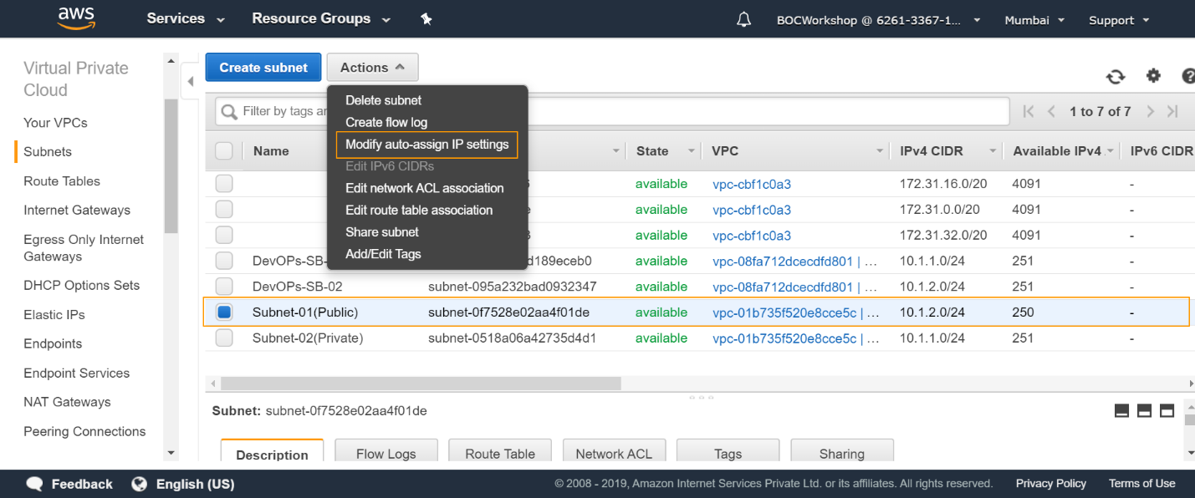

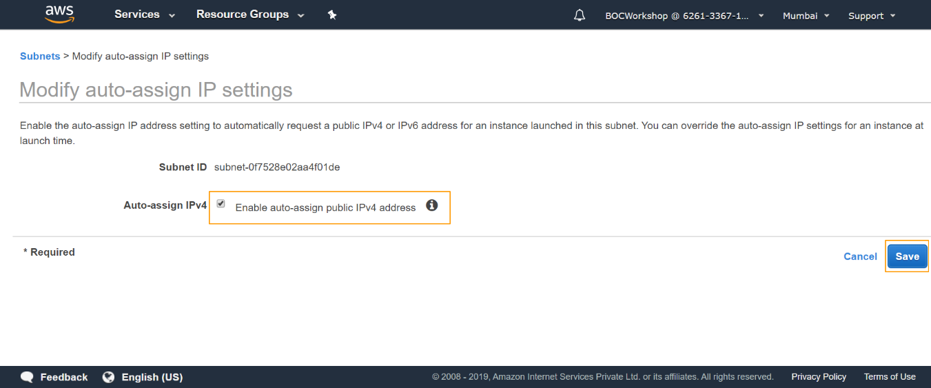

**What is Route Table?**

**Create a Route Table:**

A route table contains a set of rules, called routes that are used to determine where network traffic from your subnet or gateway is directed.

Your VPC has an implicit router, and you use route tables to control where network traffic is directed. Each subnet in your VPC must be associated with a route table, which controls the routing for the subnet (subnet route table). You can explicitly associate a subnet with a particular route table. Otherwise, the subnet is implicitly associated with the main route table. A subnet can only be associated with one route table at a time, but you can associate multiple subnets with the same subnet route table.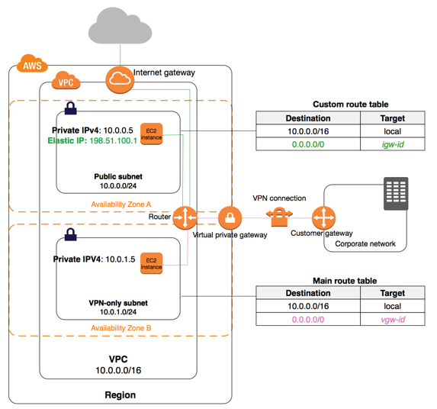

**Create Route Tables (Dashboard) – Followed by Screenshots**

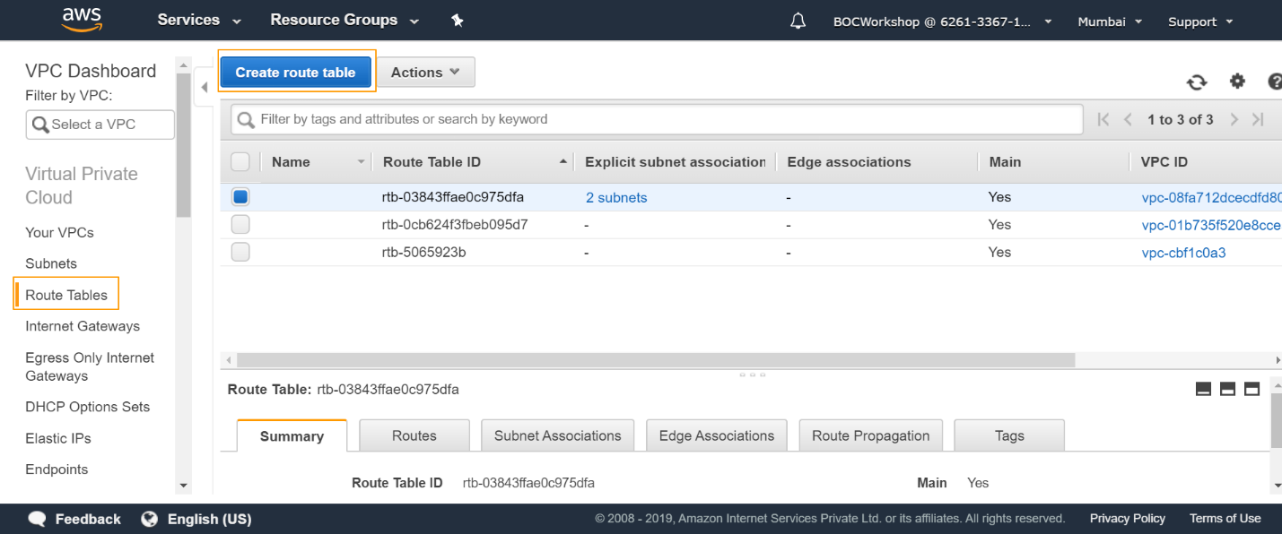

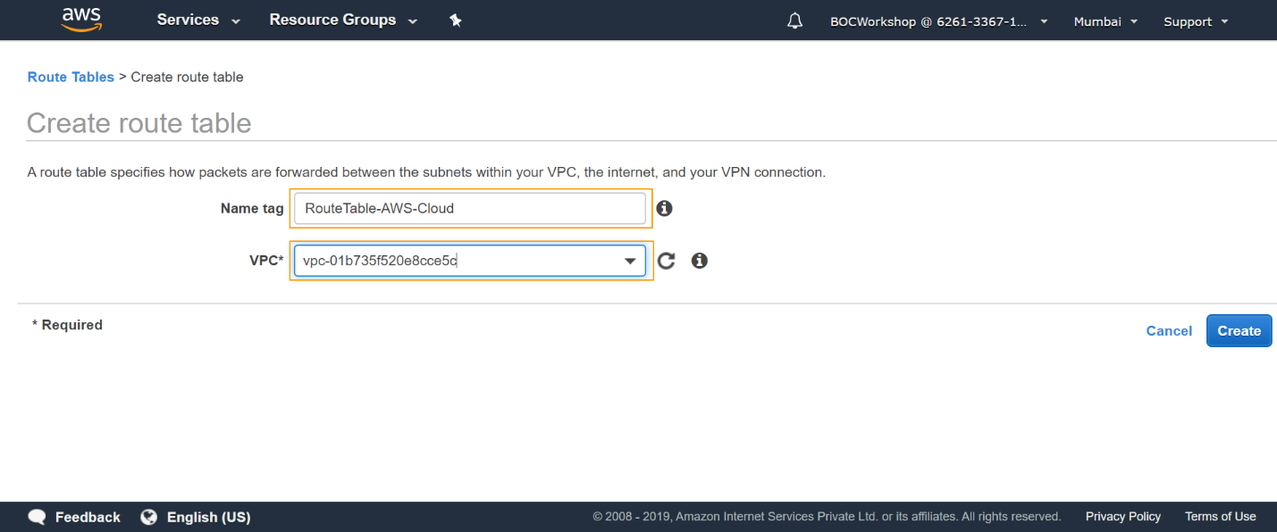

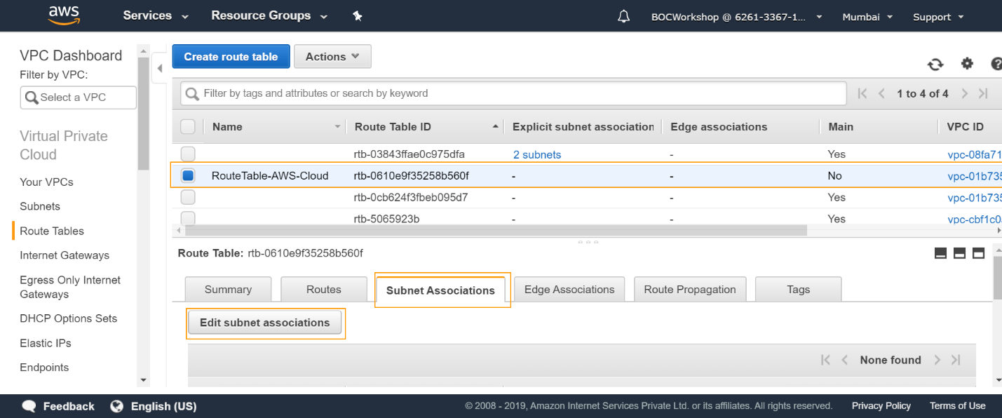

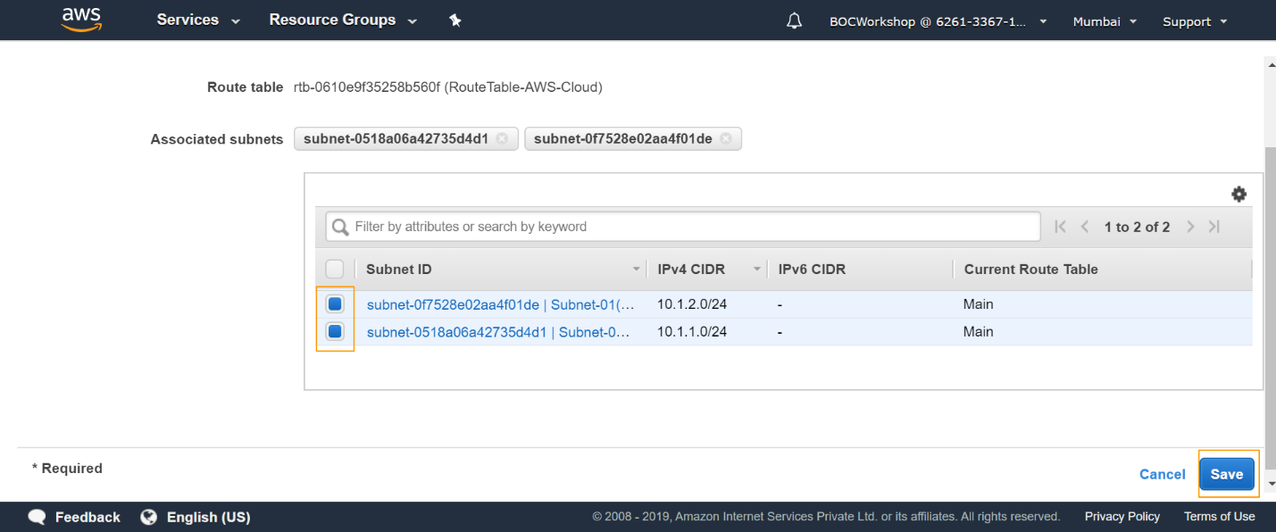

**What is IGW?**

**Internet Gateway and public subnets routing**

An Internet gateway is a horizontally scaled, redundant, and highly available VPC component that allows communication between instances in your VPC and the Internet. It therefore imposes no availability risks or bandwidth constraints on your network traffic.

An Internet gateway serves two purposes: to provide a target in your VPC route tables for Internet-routable traffic, and to perform network address translation (NAT) for instances that have been assigned public IPv4 addresses.

In order for the resources in a VPC to send and receive traffic from the Internet, the following conditions must be met:

* An [Internet gateway must be attached](http://docs.aws.amazon.com/AmazonVPC/latest/UserGuide/VPC_Internet_Gateway.html#Add_IGW_Attach_Gateway) to the VPC.
* The [route tables associated with your public subnet](http://docs.aws.amazon.com/AmazonVPC/latest/UserGuide/VPC_Route_Tables.html) (including [custom route tables](http://docs.aws.amazon.com/AmazonVPC/latest/UserGuide/VPC_Internet_Gateway.html#Add_IGW_Routing)) must have a route to the Internet gateway.
* The [security groups](http://docs.aws.amazon.com/AmazonVPC/latest/UserGuide/VPC_Internet_Gateway.html#Add_IG_Security_Groups) associated with your VPC must allow traffic to flow to and from the Internet.
* Any instances in the VPC must either have a [public IP address or an attached Elastic IP address](http://docs.aws.amazon.com/AmazonVPC/latest/UserGuide/VPC_Internet_Gateway.html#Add_IG_EIPs).

**Creation of IGW (Internet Gateway): Screenshot**

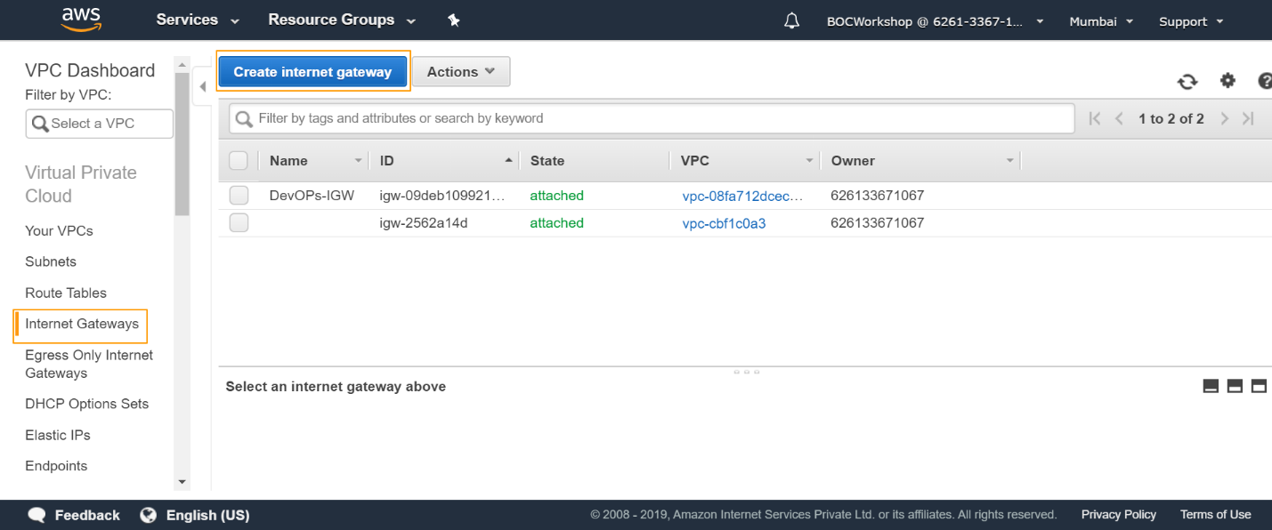

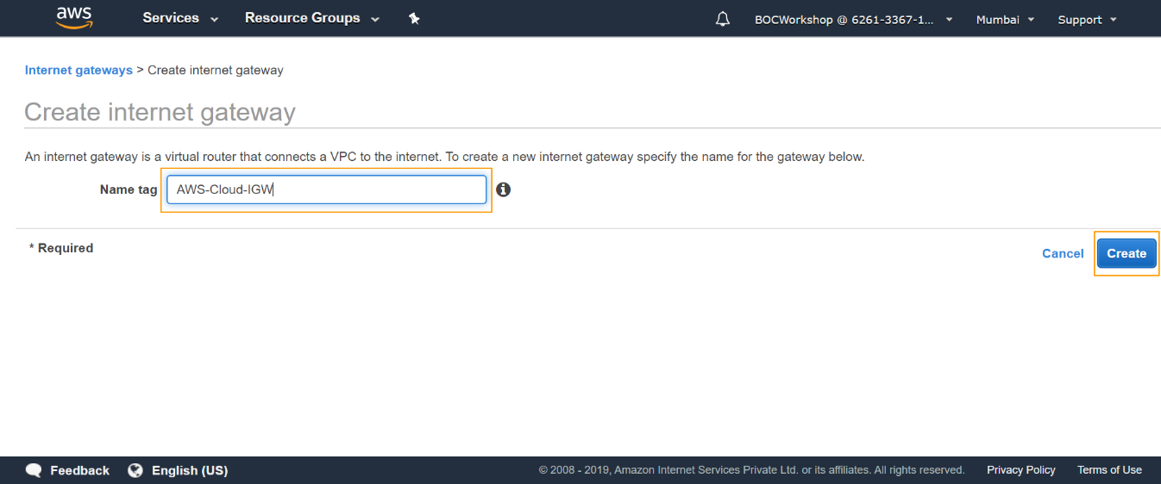

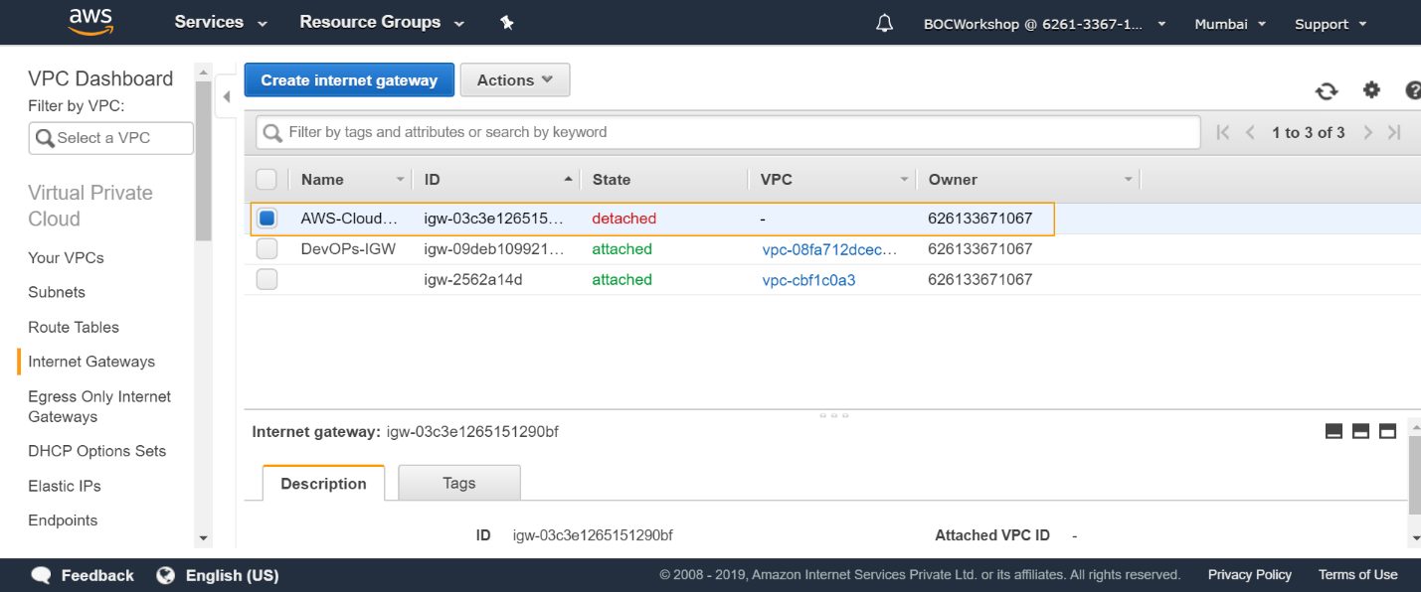

**Attach an Internet gateway**

Follow these steps to attach an Internet gateway to your VPC to enable communication of the public subnets with the Internet:

* Navigate to the AWS console -> Services.
* Under the Networking & Content Delivery section, choose VPC.
* Navigate to Virtual Private Cloud -> Internet Gateways.
* Click Create Internet Gateway.
* Type a name in the Name tag text box and click Yes, Create.

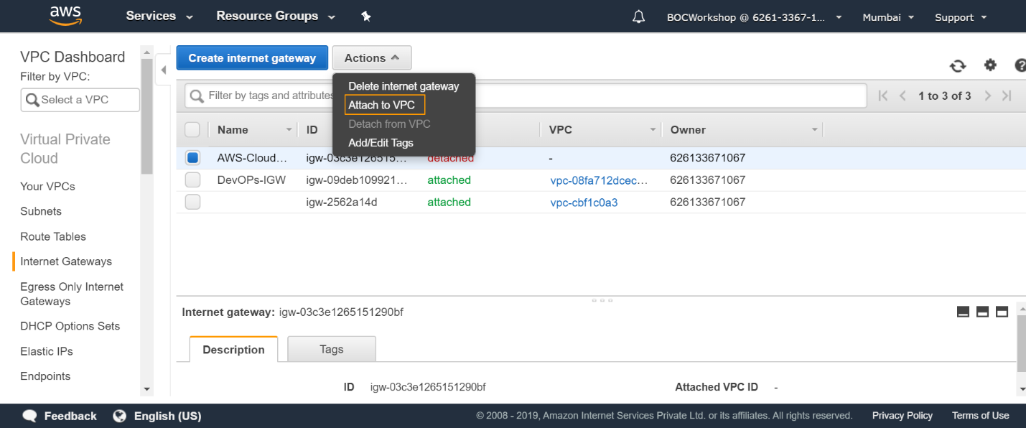

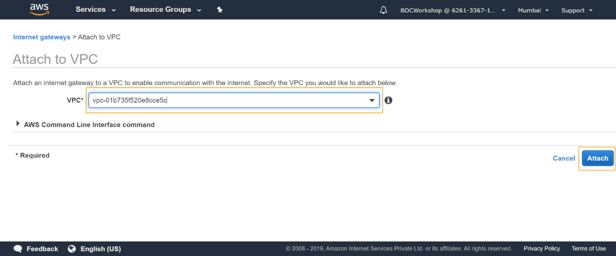

**Routing of public subnets**

Now you need to configure the routing for your public subnets. Enable traffic from your public subnets to Internet by using the internet gateway attached to the VPC.

**Configure the public subnets Route Table:**

* Navigate to VPC Dashboard -> Subnets.
* Select your first public subnet from the list and navigate to its Summary section.
* Click on the name of the Route Table of the subnet.
* You are then redirected to the Route Table in the Virtual Private Cloud -> Route Tables section.
* Add two routes for the Route Table - one for the traffic to the Internet to be routed using the Internet Gateway.

Add new rules: for destination type 0.0.0.0/0 (all packets for the internet) and for target choose the Internet Gateway you have created as in the previous subtopic.

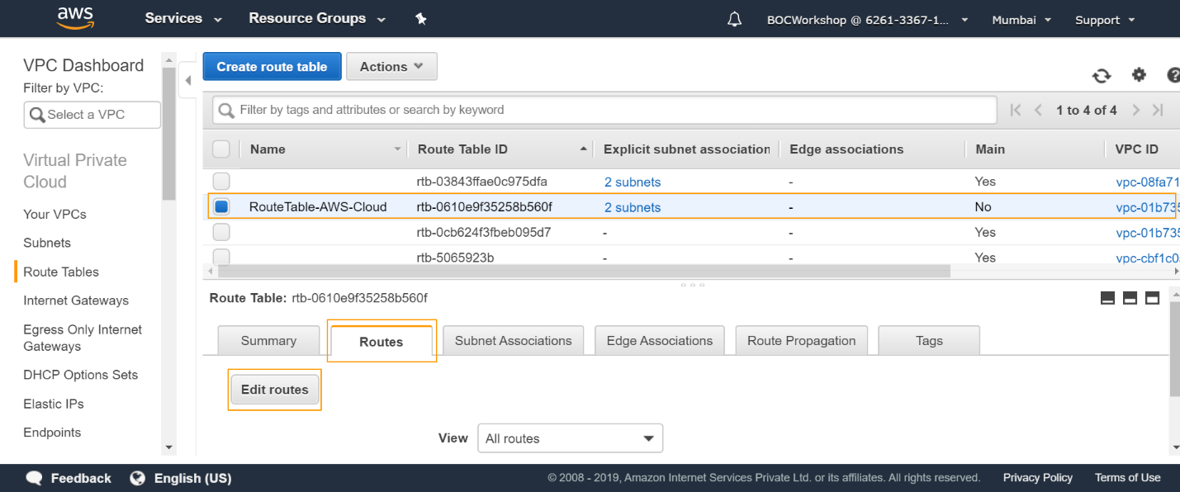

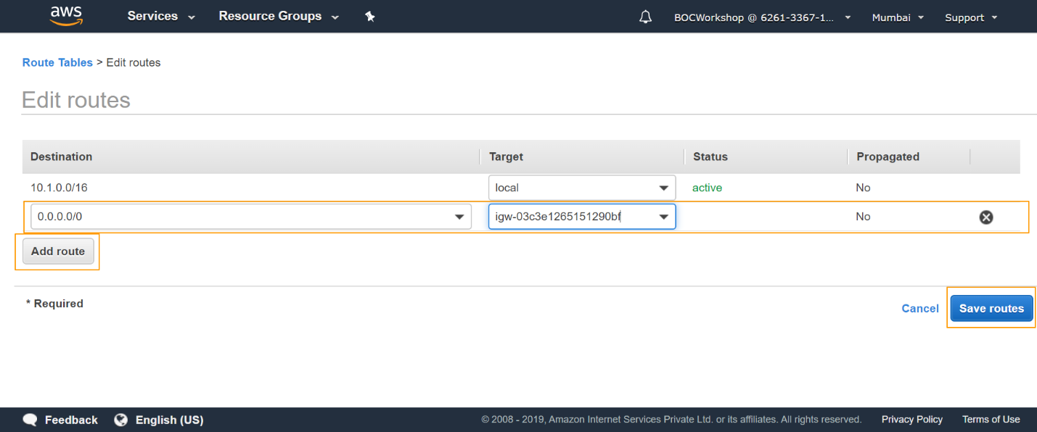

**What is Security Group?**

**Create a Security Group:**

A security group acts as a virtual firewall to control the traﬃc for its associated instances. To use a security group, you add the inbound rules to control incoming traﬃc to the instance, and outbound rules to control the outgoing traﬃc from your instance. To associate a security group with an instance, you specify the security group when you launch the instance. If you add and remove rules from the security group, we apply those changes to the instances associated with the security group automatically.

Your VPC comes with a default security group. Any instance not associated with another security group during launch is associated with the default security group. In this exercise, you'll create a new security group, Webservers, and specify this security group when you launch an instance into your VPC.

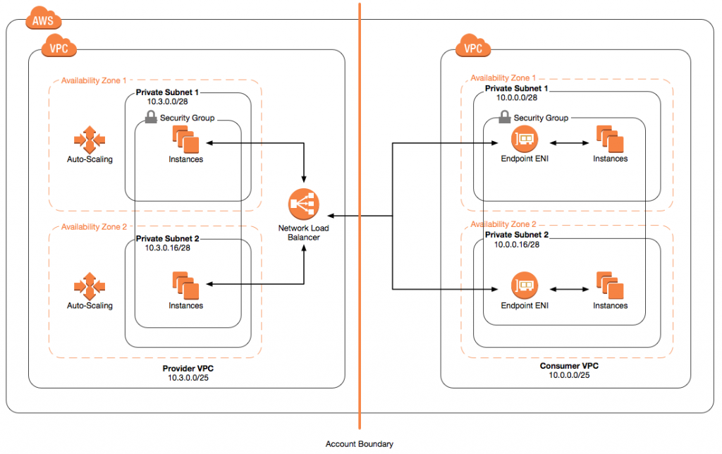

**Create Security Groups (Dashboard) – Followed by Screenshots**

